Test Document

User Stories:

1. As the API Consumer, I want to create a fighter, so that I can add some new fighters to the table
2. As the Store Administrator, I want to be able to search the fighters table so that I can easily find the information I need
3. As a Customer, I want to be able to delete a fighter, so that I can remove an unwanted fighter if needed.

Test Cases:

|  |  |
| --- | --- |
| User Story 1 | As the website user, I want to be able to create a fighter, so that I can add new ones when they are released |
| Test Case ID | 1 |
| Description | Create a fighter: fighter successfully created |
| Preconditions | 1. XAMPP is running 2. The browser is open 3. The database is available |
| Actions | 1. The address ‘http://localhost:4006/TekkenApp/’ is entered in the browser 2. The ‘Create Fighter’ link on the navbar is pressed 3. The details are filled in 4. The ‘Create Fighter’ button is pressed |
| Expected Results | 1. A notification pops up with the following message: “Successfully created new fighter” 2. The table reloads 3. The fighter is in the table |
| Test Status | Passed |

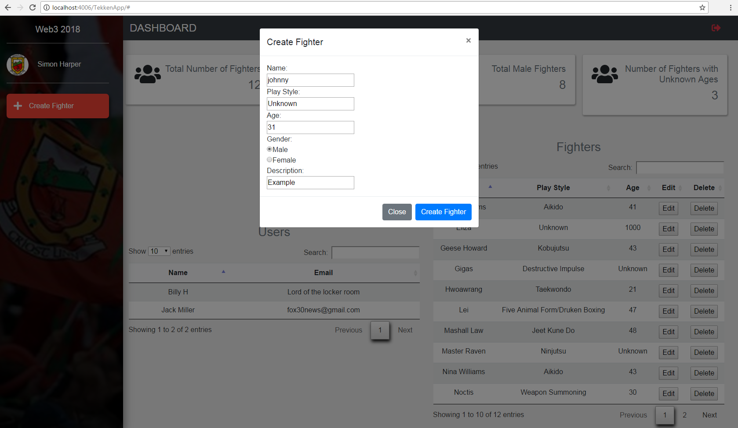

|  |  |
| --- | --- |
| User Story 2 | As the website user, I want to be able to edit a fighter, so that I can edit the data of a fighter |
| Test Case ID | 2 |
| Description | Edit a fighter: fighter successfully edited |
| Preconditions | * XAMPP is running * The browser is open * The database is available |
| Actions | * The address ‘http://localhost:4006/TekkenApp/’ is entered in the browser * The ‘Edit’ button on the table row is pressed * The details are filled in * The ‘Edit Fighter’ button is pressed |
| Expected Results | 1. A notification pops up with the following message: “Successfully edited new fighter” 2. The table reloads 3. The edited fighter is on the table |
| Test Status | Passed |

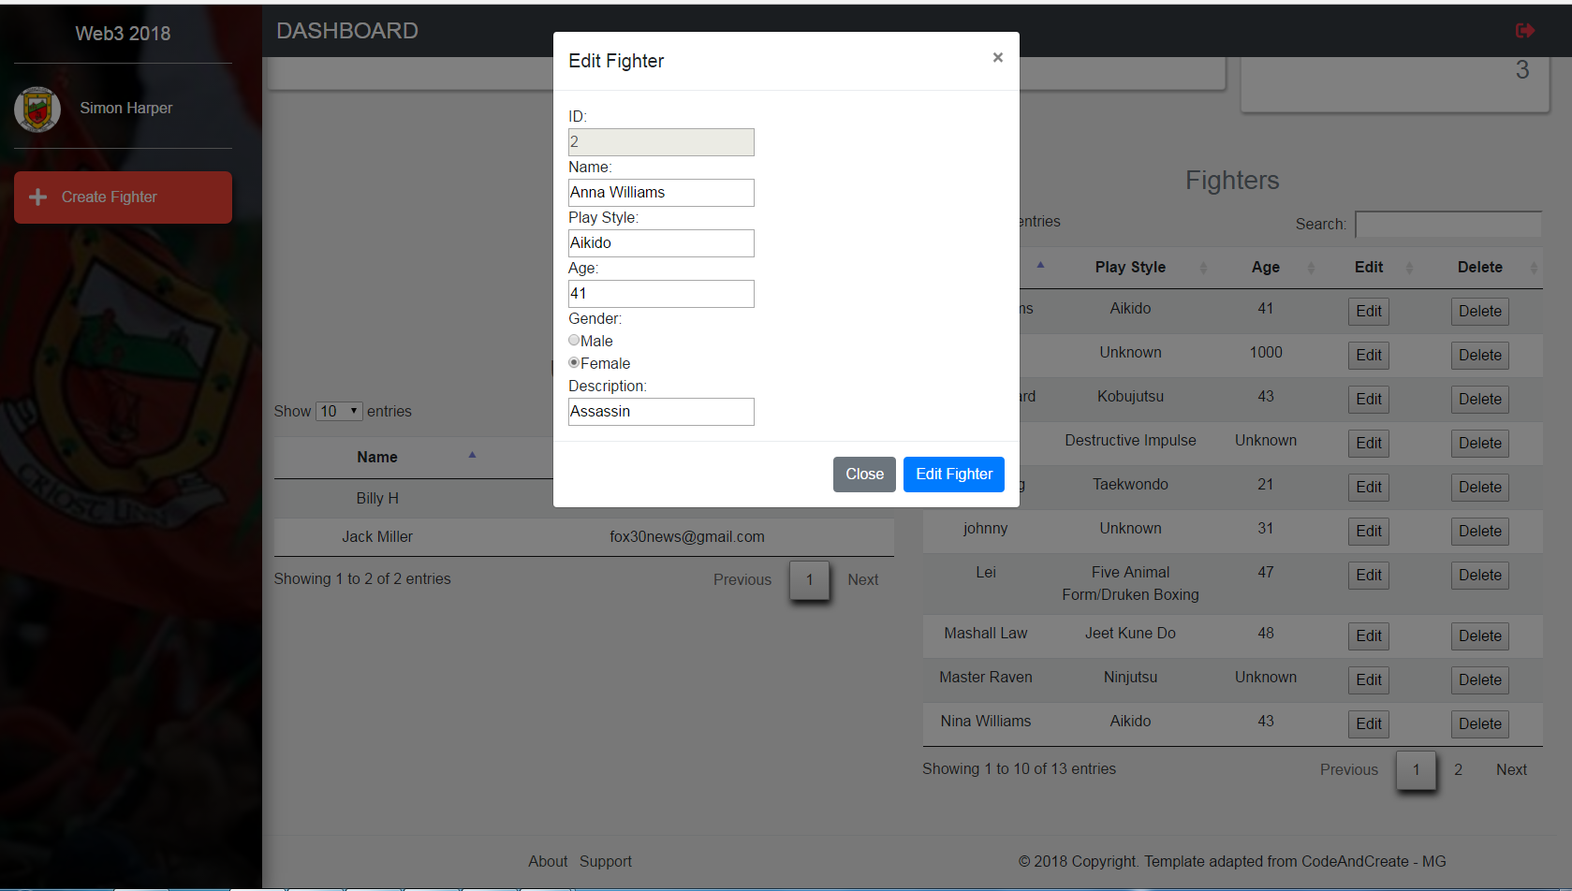

|  |  |
| --- | --- |
| User Story 3 | As a Customer, I want to be able to delete a fighter, so that I can remove an unwanted fighter if needed. |
| Test Case ID | 2 |
| Description | Delete a fighter: fighter successfully deleted |
| Preconditions | * XAMPP is running * The browser is open * The database is available |
| Actions | * The address ‘http://localhost:4006/TekkenApp/’ is entered in the browser * The ‘Delete’ button on the table row is pressed |
| Expected Results | * A notification pops up with the following message: “Successfully Deleted fighter” * The table reloads * The deleted fighter is no longer on the table |
| Test Status | Passed |

